# Preliminaries - MATLAB

* + indexing arrays (linear vs ij)
  + xy vs ij - coordinates for arrays and imagens
  + concatenation
  + I(:), index vs for loops

# LAB 1 (2 classes)

# RGB+D Cameras: Image, 3D point clouds and camera model



Suggested readings

"Kinect" (depth) cameras provide 2 type of images: RGB and DEPTH

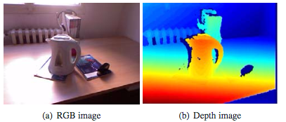

Q: What coordinate is the "depth" ? How is it obtained ?

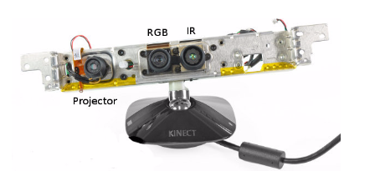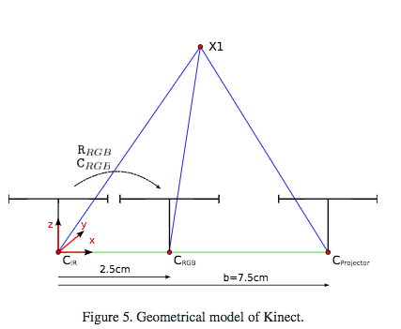

Tasks:

1. See RGB and Depth images
   1. display and interpret images
   2. display R,G,B in separate figures
2. Display depth
   1. depth as image
   2. depth as a surface
   3. point cloud, mesh
   4. depth image vs. point cloud

Question: What is the "best" representation ?

edges

Dataset:

Load depth image from the lab (link)

read image from file (link)

load point cloud (link)

http://printart.isr.ist.utl.pt/piv/lab/pivlab1/

CODE GIFT - getting the triangular mesh from ordered points.

Display a triangular surface (top triangles)

J=repmat((1:639),479,1);

I=repmat((1:479)',1,639);

I1=[I(:), I(:), I(:)+1];

J1=[J(:), J(:)+1, J(:)+1];

ind1=(J1-1)*480+I1;

%%

zs=xyz(ind1(:,1),3).*xyz(ind1(:,2),3) .* xyz(ind1(:,3),3);

ind1ok=find(zs>0);

trimesh(ind1(ind1ok,:),xyz(:,1),xyz(:,2),xyz(:,3))

Camera model -

* How to generate an image from 3D points?
* How to compute 3D positions from images/depth

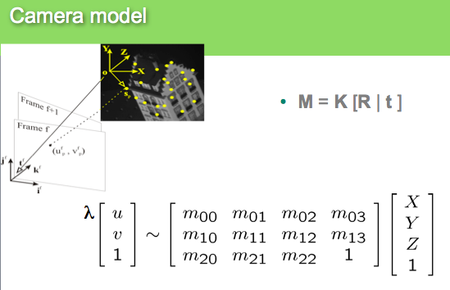

Tasks:

1. given u,v and depth compute XYZ
2. generate image projection from point cloud
3. Rotate and Translate point cloud and do the same
4. Project Point cloud in the RGB image. What about the reverse: click rgb and get the 3D!

From these two images

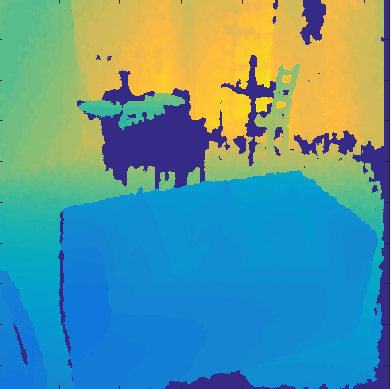 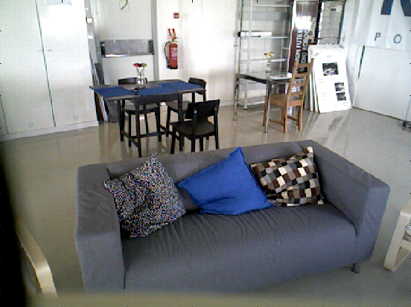

and the intrinsic and extrinsic camera parameters you should be able to "superimpose" the rgb over the depth

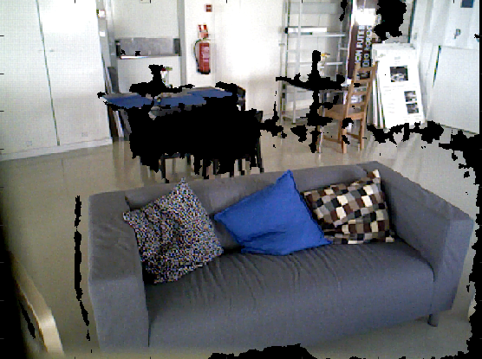

Note that now each pixel of this image is in line with the depth! So, you can compute XYZ for each pixel and create this point cloud

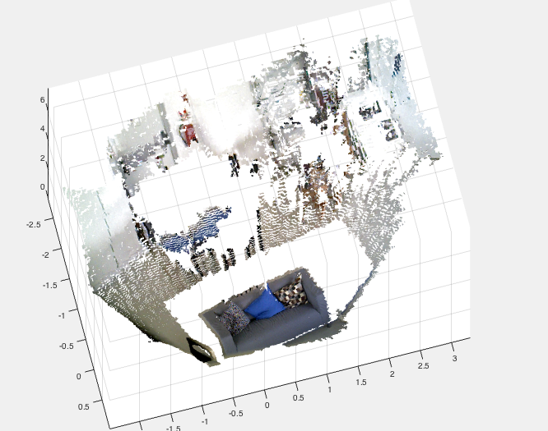

**Auxiliary code to implement these steps**

load calib_asus % Load Calibration Data for ASUS camera (similar to kinect)

load depth_10 % Load depth image

imagesc(depth_array)% Look at it...just a depth image

%Compute XYZ from depth image (u,v) and depth z(u,v)- CHECK FILE

xyz=get_xyzasus(depth_array(:),[480 640],1:640*480,Depth_cam.K,1,0);

figure

%Display point cloud

p=pointCloud(xyz)

showPointCloud(p)

%Read RGB image

im=imread('rgb_image_10.png');

figure;

imagesc(im);

%Compute "virtual image" aligned with depth

rgbd=get_rgbd(xyz,im,R_d_to_rgb,T_d_to_rgb,RGB_cam.K);

figure

imagesc([im; rgbd])

cl=reshape(rgbd,480*640,3);

p=pointCloud(xyz,'Color',cl);

figure

% Point cloud with colour per pixel

showPointCloud(p)

# LAB Topic 2 (3 classes)

# 3D point cloud registration and feature matching

Objective:

1. How to register 2 point clouds
2. Procrustes problem
3. How to match 2 images and compute 3D transformation using depth info

So, Given 2 rgb images

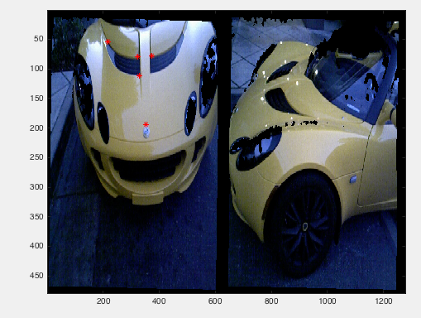

and 2 depth images

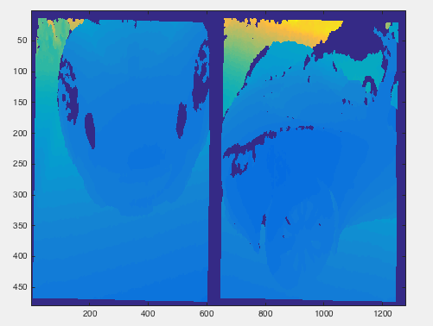

We can compute the 3D point clouds in each camera as we saw last class

3D point cloud from image 1-

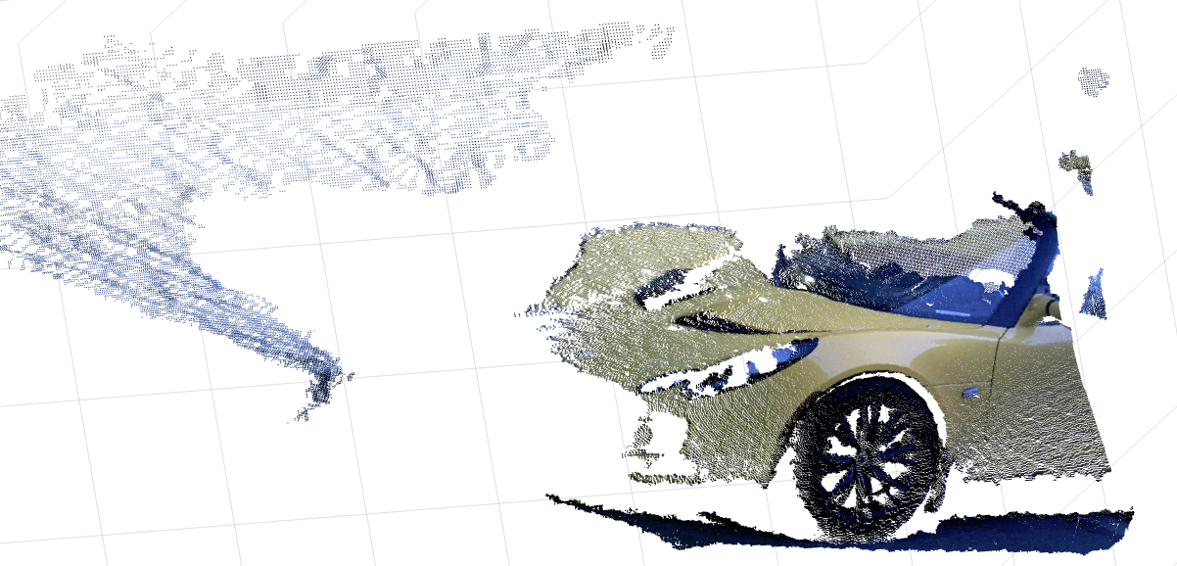

3D point cloud from image 2

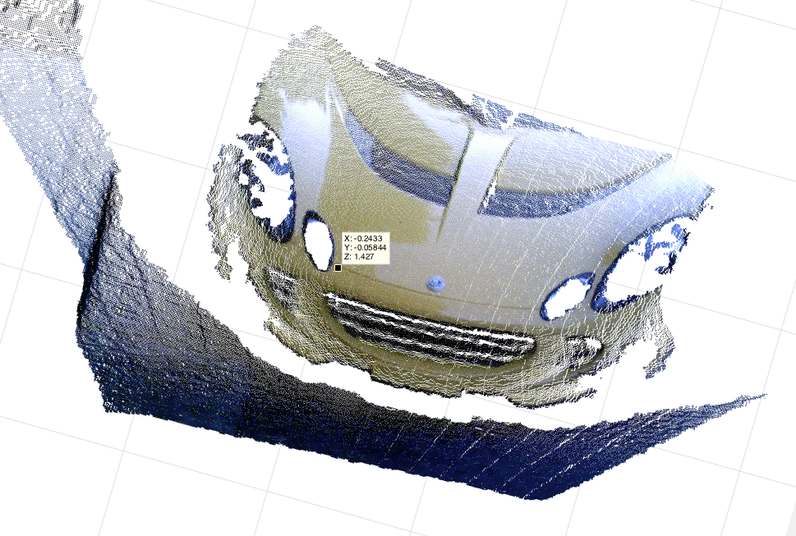

**QUESTION: How can we fuse both point clouds?**

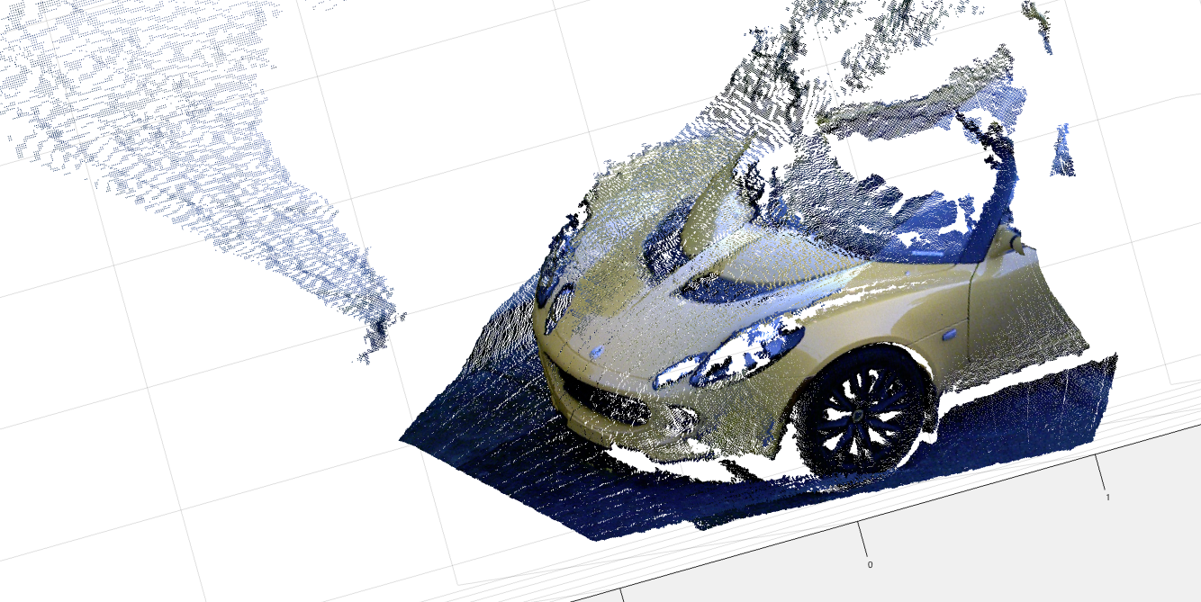

**What has to be done:**

**READINGS: Very important that you read this article**

D.W. Eggert, A. Lorusso, R.B. Fisher, Estimating 3-D rigid body transformations: a comparison of four major algorithms, Machine Vision Applications, 1997

- Match points between images

- Compute xyz from these matches

- Compute Rotation and Translation from pairs of 3D points

__________________CODE FOR Point Cloud Registration of the car dataset _____________

K=[525 0 319.5;

0 525 239.5;

0 0 1];

depth1=imread('cardepth2.png');

im1=imread('car2.jpg');

depth2=imread('cardepth393.png');

im2=imread('car393.jpg');

figure(1);

imagesc([im1 im2]);

figure(2);

imagesc([depth1 depth2]);

xyz1=get_xyzasus(depth1(:),[480 640],1:640*480,K,1,0);

xyz2=get_xyzasus(depth2(:),[480 640],1:640*480,K,1,0);

cl1=reshape(im1,480*640,3);

cl2=reshape(im2,480*640,3);

p1=pointCloud(xyz1,'Color',cl1);

p2=pointCloud(xyz2,'Color',cl2);

%%

figure(3)

showPointCloud(p1);

figure(4)

showPointCloud(p2);

%%

m1=depth1>0;

m2=depth2>0;

imaux1=double(repmat(m1,[1,1,3])).*double(im1)/255;

imaux2=double(repmat(m2,[1,1,3])).*double(im2)/255;

figure(5);

imagesc(imaux1);

figure(6);

imagesc(imaux2);

% select figure with im1 and click 5 points

%[u1,v1]=ginput(5);

%select figure with im2 and click in the corresponding points

%[u2 v2]=ginput(5);

u1 =[ 216.7007 324.5143 329.1022 352.0412 372.6864]';

v1 =[ 53.7925 80.2550 111.8629 194.9257 78.7848]';

u2=[257.9910 224.7294 135.2670 42.3638 192.6147]';

v2=[87.6057 108.1876 124.3591 168.4632 130.9747]';

figure(5);hold on;plot(u1,v1,'*r');hold off;

figure(6);hold on;plot(u2,v2,'*r');hold off;

ind1=sub2ind([480 640],uint64(v1),uint64(u1));

ind2=sub2ind([480 640],uint64(v2),uint64(u2));

%% Compute Centroids

cent1=mean(xyz1(ind1,:))';

cent2=mean(xyz1(ind2,:))';

pc1=xyz1(ind1,:)'-repmat(cent1,1,5);

pc2=xyz2(ind2,:)'-repmat(cent2,1,5);

[a b c]=svd(pc2*pc1')

R12=a*c'

%%

xyzt1=R12*(xyz1'-repmat(cent1,1,length(xyz1)));

xyzt2=xyz2'-repmat(cent2,1,length(xyz2));

T=cent2-R12*cent1;

%%

ptotal=pointCloud([xyzt1';xyzt2'],'Color',[cl1;cl2]);

figure(7);

showPointCloud(ptotal);

**-HOMEWORK -**

CHALLENGE 1

Click in one (or more) points in image 1 (red dots) and

Predict where these points are located in image 2 (yellow dots). You have to use the intrinsics for depth and rgb as well as the extrinsics between both "cameras".

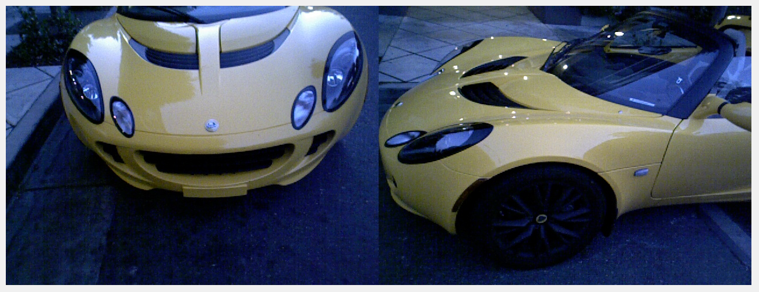

CHALLENGE 2

Consider now a third image without common points with image 1

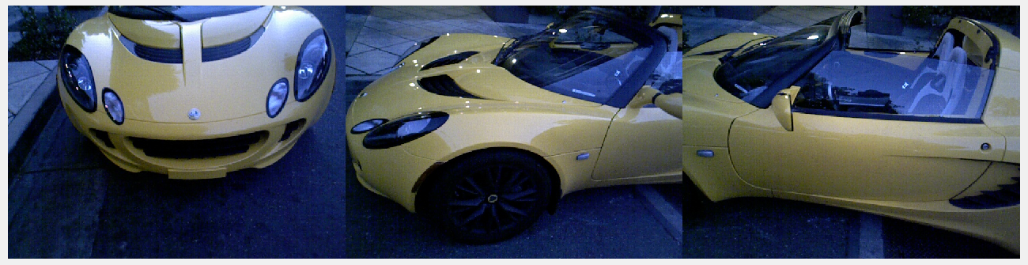

image 1 image 2 image 3

Using the depth image 3 (and the point cloud)

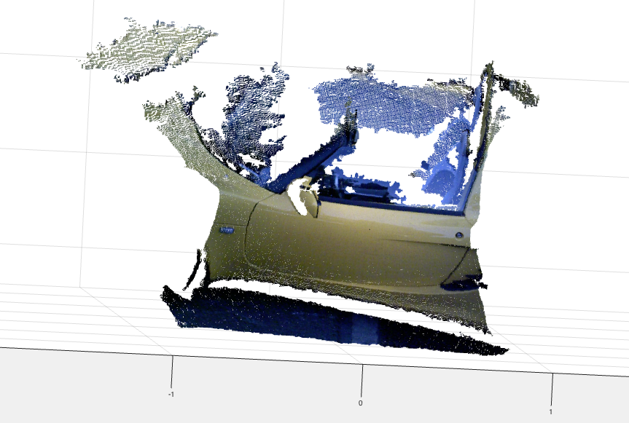

Fuse all 3 images !

AND YOU WILL BE ALMOST DONE WITH PART 1 !

This is what you will get :-)

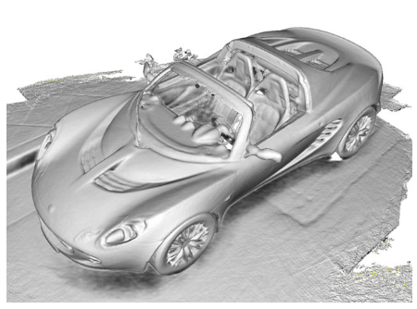

3D point cloud registration - ICP

Objective:

1. How to register 2 point clouds only from 3D data (ICP) -
2. How to maintain a stable number of points after registering several pointclouds
3. How to match 2 images

1 and 2 are explained in the board... and here!

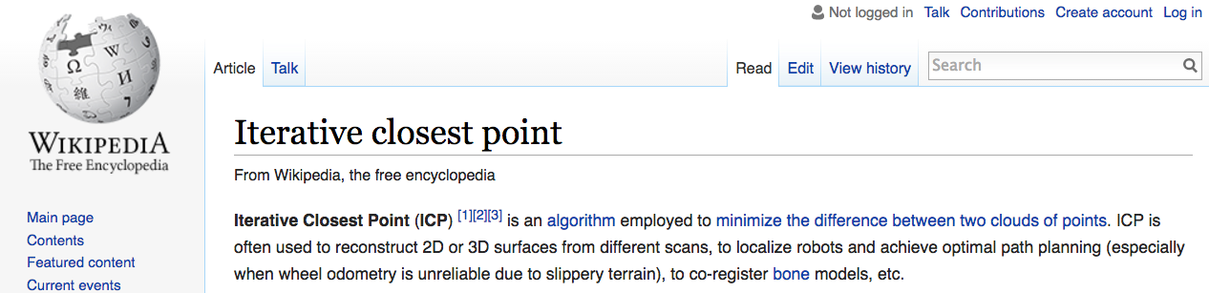

# 3 - How to match 2 images (2 classes)

First we need to select points, then a criterion to match them

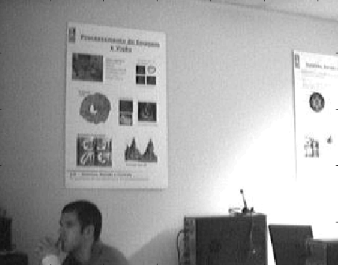

Let's convolve with 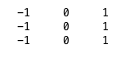 and with 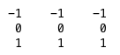

in matlab

f=[1 0 -1;1 0 -1;1 0 -1];

imc1=conv2(img, f);

imc2=conv2(img,f');

Conv2 is 2D convolution. What is "convolution" doing ?

check also with f=ones(5,5);

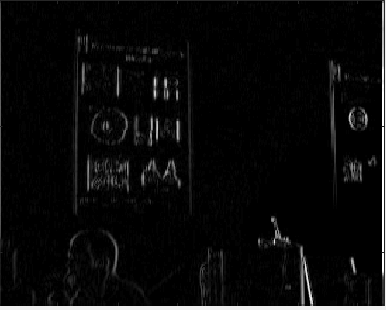 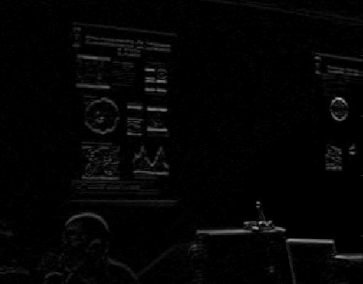



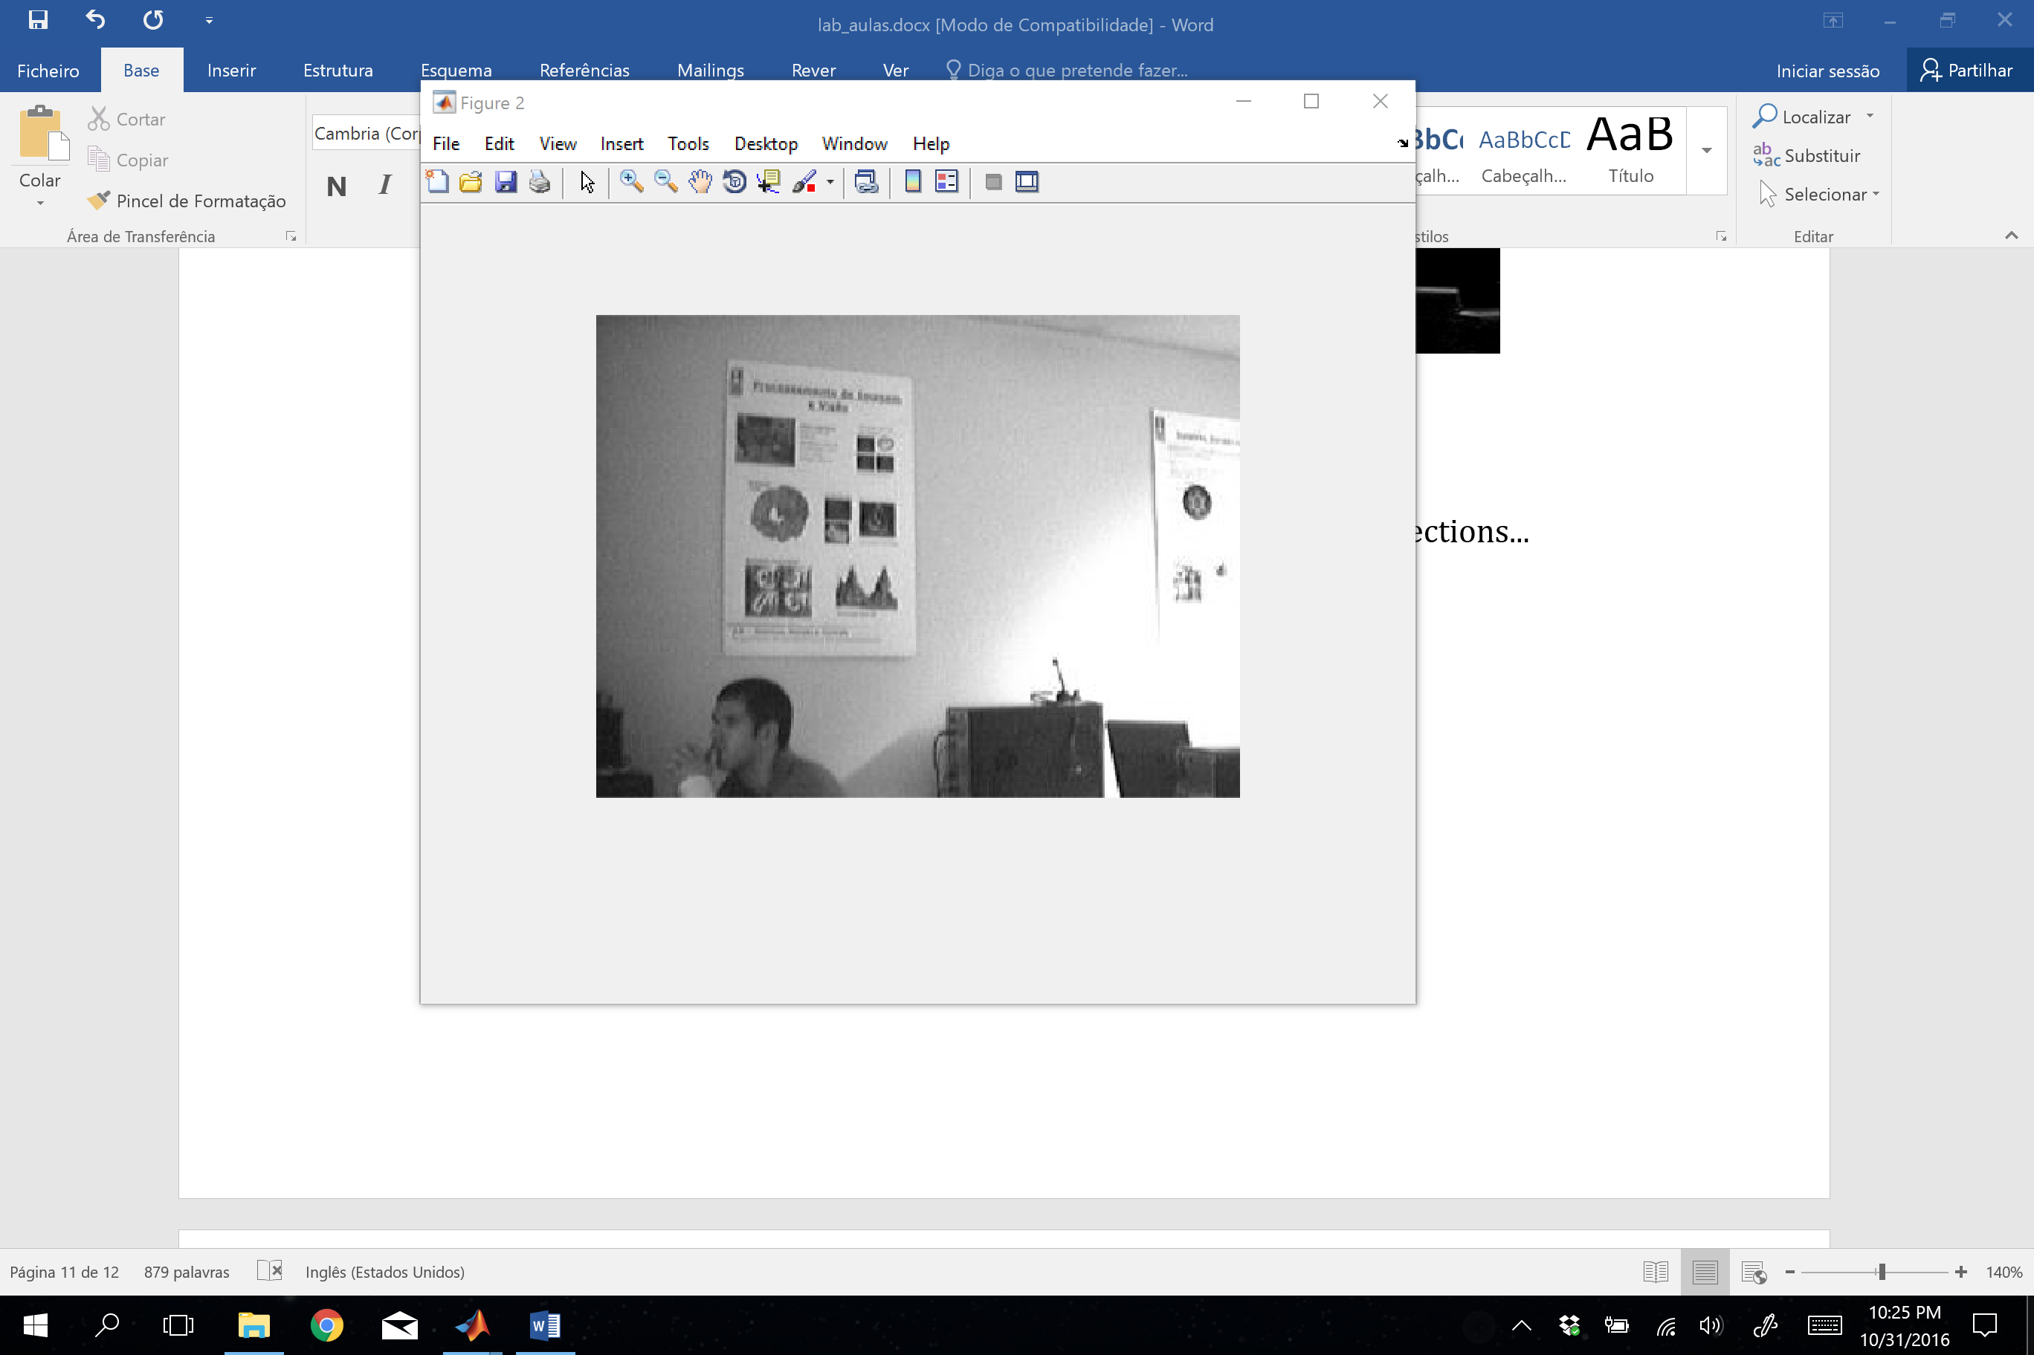



These images are the gradient (filtered with a low pass filter!) and shown superimposed in the image (red arrow).

what are good points to pick ? Points with strong gradient in both directions...

How to measure it ? Well…. Covariance of the gradient…(Check the definition of the Harris corner detection in the book/classes or the notes taken from the board!!!).

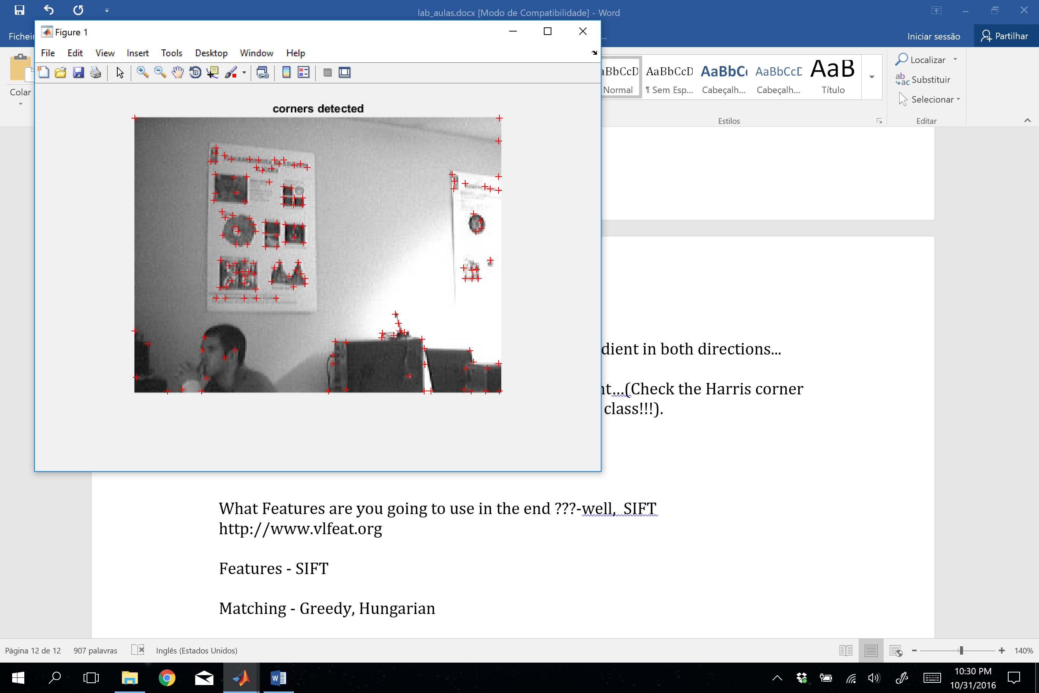



Run the code supplied :

[cim, r, c] = harris(im, sigma, thresh, radius, disp);

We saw that the points selected have the smallest eigenvalue of the gradient covariance (or the 2nd moment) in the a window (6sigma x 6sigma) above a certain value (thresh).

Check also the code we used for finding similarity using correlation between template and images

What Features are you going to use in the project?

You are going to use SIFT (check theoretical class). Particularly there is a toolbox you can use http://www.vlfeat.org



Matching - Greedy, Hungarian

# Topic 4 (1 class) – Homography: How are panoramas done?

Remember the image transformation topics in the beginning of the semester. Particularly the definition of homography.

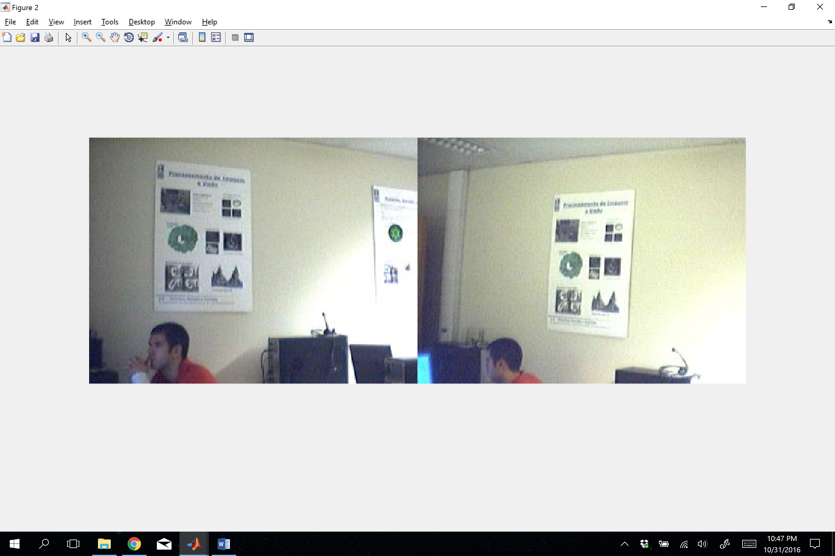



Given these 4 matches, how can we generate a frontal view ? Take notes from the board (in class) ! We will run the code in map_homography.m

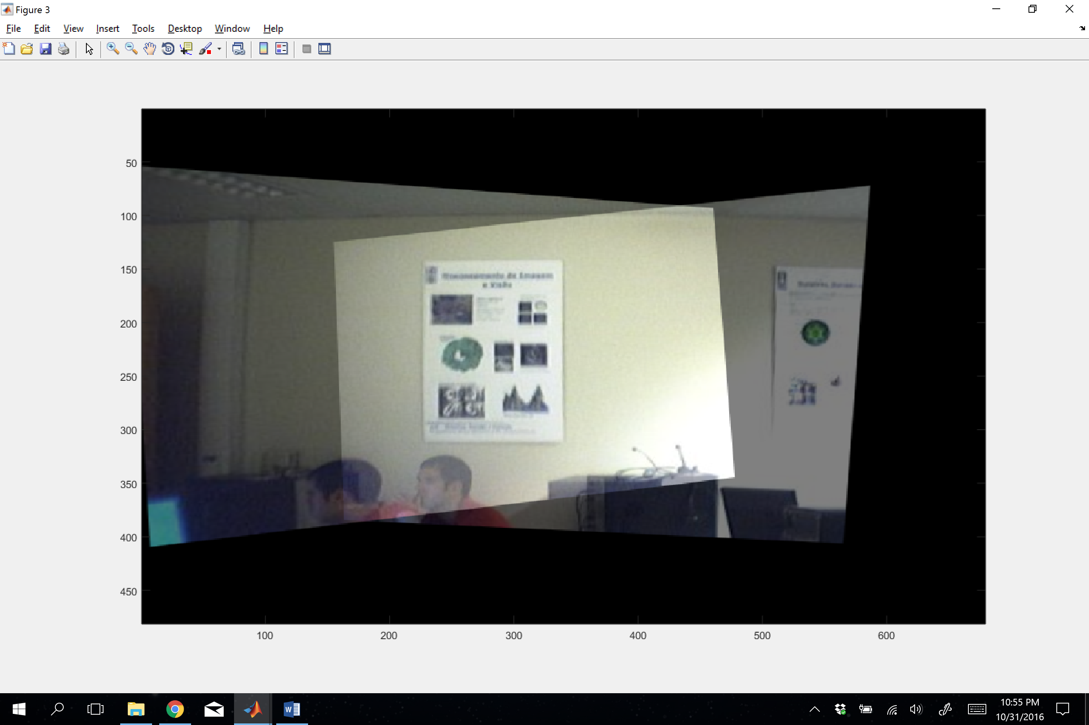



Compute homography H1 and H2 and fuse both images

parede1=imread('parede1.jpg');

parede2=imread('parede2.jpg');

%lab2 feito pelo nuno

imshow(parede1);

[u1 v1]=ginput(4);

figure;

imshow(parede2);

[u2 v2]=ginput(4);

pts=[0 0; 200 0; 200 300; 0 300];%assign coordinates for the points %in the frontal view! Why ? What else could be done ?????Are these %points unique…arbitray ????

t1=cp2tform([u1 v1],pts,'projective');

t2=cp2tform([u2 v2],pts,'projective');

im1=imtransform(parede1,t1,'Xdata',[-400 800],'YData',[-250 600]);

im2=imtransform(parede2,t2,'Xdata',[-400 800],'YData',[-250 600]);

# LAB Topic 5 (1 class) – Color

What is color ? How are defined color images ?